Overcoming fear!

2 Timothy 1:
6 ¶ Wherefore I put thee in remembrance that thou stir up the gift of God, which is in thee by the putting on of my hands.
7 For God hath not given us the spirit of fear; but of power, and of love, and of a sound mind.
8 Be not thou therefore ashamed of the testimony of our Lord, nor of me his prisoner: but be thou partaker of the afflictions of the gospel according to the power of God;
9 Who hath saved us, and called us with an holy calling, not according to our works, but according to his own purpose and grace, which was given us in Christ Jesus before the world began,
10 But is now made manifest by the appearing of our Saviour Jesus Christ, who hath abolished death, and hath brought life and immortality to light through the gospel:
11 Whereunto I am appointed a preacher, and an apostle, and a teacher of the Gentiles.
12 For the which cause I also suffer these things: nevertheless I am not ashamed: for I know whom I have believed, and am persuaded that he is able to keep that which I have committed unto him against that day.
13 Hold fast the form of sound words, which thou hast heard of me, in faith and love which is in Christ Jesus.
14 That good thing which was committed unto thee keep by the Holy Ghost which dwelleth in us.

Lets look at 2 Timothy 6:7-8
7 For God hath not given us the spirit of fear; but of power, and of love, and of a sound mind.
8 Be not thou therefore ashamed of the testimony of our Lord, nor of me his prisoner: but be thou partaker of the afflictions of the gospel according to the power of God;

God has not give us the spirit of Fear,

No God does not give us a spirit of Fear,

Satan is the bringer of fear

He tries to make us fearful to reach out to people we don’t know.

1. Fear binds our witness
Bondage of fear:
When we see that soul in need, and the Holy spirit whispers go share me with them.

Do we cower to follow through?

There are many types of fear, but the type that does some of the most eternal damage is the fear of witnessing to others.

You know there can be grave consequences of the fear of man, the fear of witnessing to others!

2. Consequences of fear:
Are we aware of the consequences of not witnessing?
Not telling the sinner the errors of his way?

Ezekiel 3:
18 When I say unto the wicked, Thou shalt surely die; and thou givest him not warning, nor speakest to warn the wicked from his wicked way, to save his life; the same wicked man shall die in his iniquity; but his blood will I require at thine hand.
19 Yet if thou warn the wicked, and he turn not from his wickedness, nor from his wicked way, he shall die in his iniquity; but thou hast delivered thy soul.
20 Again, When a righteous man doth turn from his righteousness, and commit iniquity, and I lay a stumblingblock before him, he shall die: because thou hast not given him warning, he shall die in his sin, and his righteousness which he hath done shall not be remembered; but his blood will I require at thine hand.
21 Nevertheless if thou warn the righteous man, that the righteous sin not, and he doth not sin, he shall surely live, because he is warned; also thou hast delivered thy soul.

- The Consequence to Their Soul:
“the same wicked man shall die”

They will parish in the torment for Eternity!

- The Consequence of our soul

A Poem titled “My Friend” from the book:
One Thing you Can’t Do in Heaven
by Mark Cahill Page 52:

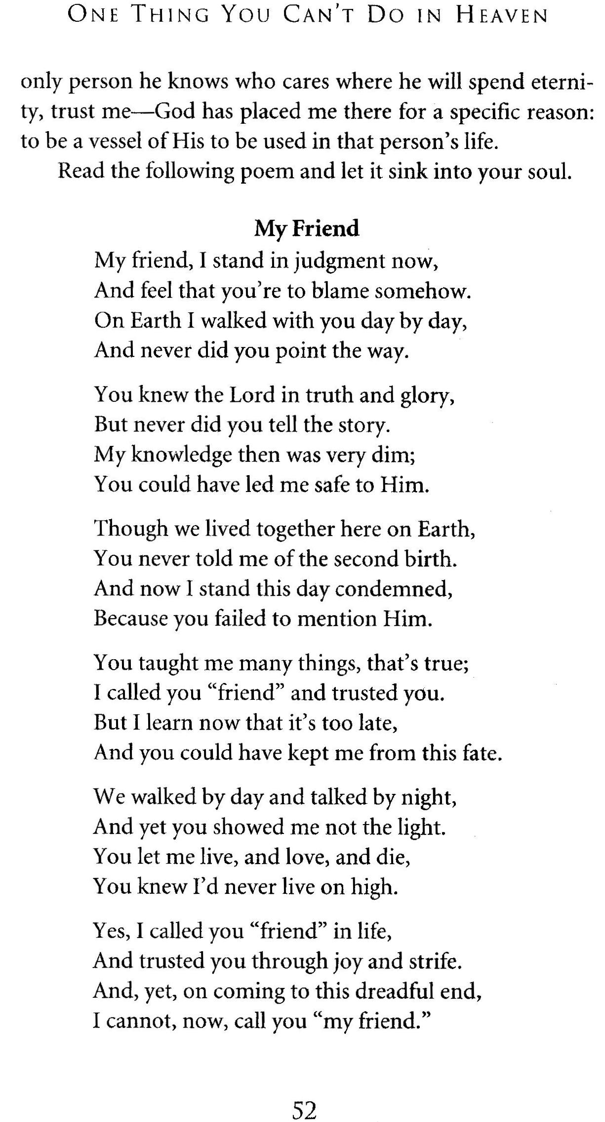

Illustration of preaching on at the convenience store in Dushore I heard there screams from Hell.

I can tell of another situation where the Lord taught me a similar lesson:
Illustration of rebuke for the young lady at Sheetz

Revelation 21:8 But the fearful, and unbelieving, and the abominable, and murderers, and whoremongers, and sorcerers, and idolaters, and all liars, shall have their part in the lake which burneth with fire and brimstone: which is the second death.

3. How do we break the bondage of fear?
A. Identify it.
What are we afraid of when it comes to witnessing?
  - Rejection?
  - Intimidation?
  - Physical Harm?
  - Humiliation? Someone may make fun of you?
  - Ashamed? Looking at verse 8
Be not thou therefore ashamed of the testimony of our Lord, nor of me his prisoner: but be thou partaker of the afflictions of the gospel according to the power of God;

Is it possible that the fear to tell others about Jesus is coming is because of being ashamed of Jesus. Are you embarrassed to speak of your Lord?
Are we afraid people at work will find out we are a Christian?
Do the people at work even know we are Christians?

If we do not confess our Saviour to others
we will grow week!

4 Principles of stay strong in the Lord:
- Wounded without the Word
- Power in Pray
- Faithful in Fellowship
- Witnessing Wins

Romans 10:10-11 For with the heart man believeth unto righteousness; and with the mouth confession is made unto salvation.
11 For the scripture saith, Whosoever believeth on him shall not be ashamed.

Whosoever believeth on him shall not be ashamed.
Whosoever believeth on him shall not be ashamed.
Whosoever believeth on him shall not be ashamed.
Whosoever believeth on him shall not be ashamed.

How do we over come our fears?
We face them head on.
- Must Face your fear to overcome it.
  - 1John 4:18 There is no fear in love; but perfect love casteth out fear: because fear hath torment. He that feareth is not made perfect in love.

Therefore latch onto God and break that
bondage of fear!

How do we break the bonds of fear?
- Call on Jesus Christ for deliverance
  - Be filled with the Holy Ghost,
  - Pray till your soul is set a-fire!
  - The Go with courage!

6 ¶ Wherefore I put thee in remembrance that thou stir up the gift of God, which is in thee by the putting on of my hands.
7 For God hath not given us the spirit of fear; but of power, and of love, and of a sound mind.
Summary:

1. Fear binds our witness

2. Consequences of fear:
A. Consequence of their soul
B. Consequence of your soul

3. How to break the bondage of fear.
A. Identify it.
B. Face it.
C. Call on Jesus Christ for deliverance

Testimonies of newly saved because of reaching out
Jacobs mom… Labor day 2001
Elwood Benjamin, hospital
Rick Chamberlain
Dorothy Iverson – Hospital
Bus Children’s mother Kim Ayres
Mary Gene – Hospital
Hospital roommate

Gerald Kinsman
Went to see a man who was dying in the nursing home, he was in terrible pain. I gave him the basic gospel message and talked about victory over sin. The man wept his way to Jesus.
The professing Christian wife who ask that I come said she never seen anything like this before. But my pastors have been in to talk with him many times and she never seen anything like this before.

God wants us to over come our fears

Stir up the gift that is with in you.
Look around you there are souls dying everywhere, the hour is at hand, we need to pray and do all that we can for Christ,

Stir up the Gift that is within you and pray and prevail for souls.

Christ wants to do mighty things, we must be faithful to pray.

Psalms 126:6 He that goeth forth and weepeth, bearing precious seed, shall doubtless come again with rejoicing, bringing his sheaves with him.

Let us weep out to God for forgiveness of our weaknesses, call out to God to save our children, our towns, our state, our nation, and the World.

I close with this Illustration:
I once had a dream/vision of the Lost that looked like this:
People lined up in lines as far as one can see for miles walking up a cliff called eternity and stepping right of the edge ignorantly not knowing their fate of death.
The world is like these masses of people walking off the edge of a cliff and plummeted to their death and the only thing standing between them and certain death is
each of us!

We can pull them from the lines and win them to Jesus. Show them the cliff they are about to step off.

It’s not just the pastors, evangelist, and Christian works, it is every born again Christians duty to win the Lost.

